Sample: Teacher support materials

0000.doc
Course |  | pp. 10-11 | pp. 12-13 | pp. 14-15 | pp. 16-17 | pp. 18-19 | pp. 20-21
Content Organiser |  | Unit PA  Discovery | Unit PB  Expression | Unit 1A  Experiences | Unit 1B  Explorations | Unit 1C  Inspirations | Unit 1D  Investigations
Art Making | Inquiry | - experiment with drawing both observed and expressive  - manipulate materials to produce artwork  - follow steps and processes to create artwork | - use drawing as a means of expression  - explore ways of manipulating materials to develop artworks such as bending wire to create an armature  - follow steps and processes to create artwork | - explore drawing and different ways to represent ideas, objects and subject matter  - explore themes and develop artworks using a variety of stimulus materials and investigative approaches  - follow steps, procedures and processes to produce artwork | - explore ways to create artworks using a range of stimulus materials, sources of information and drawing approaches  - develop artwork through experimentation and media manipulation  - document steps, procedures and processes used to create artwork | - use direct observation, expressive and exploratory drawing to create artwork  - explore alternatives, experiment and make informed decisions about the development of artwork  - organise information, research, plan and document design development process | - use observed, spontaneous and analytical drawings to develop artwork  - manipulate media and use a variety of investigative approaches to develop and produce artwork  - gather, collect and organise information, research and inspiration to plan and develop artwork
Art Making | Visual language | - focus on specific visual language to create artwork such as repeating shape to create pattern  - develop a basic understanding of art elements and principles | - experiment with visual language to create artwork such as using contrasting colours  - use basic visual language to represent experiences and express feelings such as using line to capture movement. | - explore visual language in directed tasks and activities  - develop artworks using specific visual art language | - explore ways to use visual language in the development of artwork | - use strategies for developing visual language in artwork, | - use visual language in the development and production of artwork
Art Making | Visual influence | - use specific artists or artworks to produce artwork such as Andy Warhol and pop art  - copy similar techniques, subject matter or approaches to own artwork | - consider specific artists and their artworks when producing artworks such as Van Gogh and Starry Night  - refer to stylistic features of specific to develop and express ideas such as Egyptian art and hieroglyphics. | - examine specific artists and artworks with similar techniques, subject matter or approaches  - select sources of information and inspiration to develop own artwork | - explore techniques used by different artists | - use inspiration from selected artists, genres, cultures and the immediate environment to develop artwork. | - collect and use inspiration gathered from across a range of artists, genres, times and places in the development of own artwork
Art Making | Presentation | - follow prescribed forms of presentation  - participate in setting up displays  - display finished artwork with an audience in mind | - make choices about how and where artworks are to be displayed.  - display finished artwork with an audience in mind | - organise work in progress and display area  - display finished artwork with an audience in mind | - record processes in developing artwork  - display finished artwork with an audience in mind | - record and arrange work in progress  - display finished artwork with an audience in mind | - organise and arrange thinking and working practices  - display selected artwork

Course |  | pp. 10-11 | pp. 12-13 | pp. 14-15 | pp. 16-17 | pp. 18-19 | pp. 20-21
Content Organiser |  | Unit PA  Discovery | Unit PB  Expression | Unit 1A  Experiences | Unit 1B  Explorations | Unit 1C  Inspirations | Unit 1D  Investigations
Art Making | Artforms, media and techniques | - apply media and demonstrated techniques appropriately in selected art forms such as blending charcoal or coiling with clay  - experiment with materials and techniques to achieve expressive results such as mixing colours to express an emotion | - experiment with a variety of given media such as weaving with natural and man made fabrics  - use specific media and demonstrated techniques such as crayon and wax resist  - use processes and conventions associated with specific art forms such as editioning a series of prints. | - test and explore media when developing artwork  - use demonstrated techniques in selected art forms | - test and experiment with materials and techniques to achieve particular effects  - apply and refine use of media and techniques when producing artwork | - test materials, explore techniques and follow processes when developing and producing artwork | - explore materials, techniques and ways to combine processes in the development and production of artwork
Art Making | Art practice | - follow structured processes to create artwork  - apply basic technical skills to produce artwork  - use safe and appropriate work practices  - respect own and others artwork. | - follow structured processes and steps to create artwork  - apply demonstrated skills to produce artwork  - use safe and appropriate work practices  - respect own and others artwork | - make sound choices when developing artwork  - use safe and appropriate work practices, respecting and acknowledging the work of others | - apply skills and processes in specific art forms  - follow correct processes to develop and produce artwork  - use safe and appropriate work practices, respecting and acknowledging the work of others | - experiment and selectively apply materials and skills to produce artwork  - make appropriate and considered choices when developing artwork  - follow correct health and safety practices, respecting and acknowledging the work of others  - examine a variety of art forms and visual arts practices, referencing sources of information | - experiment with materials, skills and processes to develop artwork  - follow correct health and safety practices, respecting and acknowledging the work of others  - examine a range of visual arts practices by selectively apply skills and processes to own artwork
Art Making | Reflection | - describe success of artwork and personal accomplishment | - engage in individual and/or group evaluation of artwork.  - identify strengths and weaknesses of own work.  - appraise finished artwork and discuss ways to improve | - identify and discuss ways to improve artwork  - evaluate success of finished artwork | - appraise finished artwork and identify ways to improve  - ongoing self-evaluation | - self evaluate finished artworks using a given criteria and identify ways to improve | - self-evaluate the process and product of own work using a response framework

Course |  | pp. 22-23 | pp. 24-25 | pp. 26-27 | pp. 28-29
Content Organiser |  | Unit 2A  Differences | Unit 2B  Identities | Unit 3A  Commentaries | Unit 3B  Points of view
Art Making | Inquiry | - explore approaches to drawing including representational, expressive, decorative and symbolic methods to develop artwork  - consider a variety of ways to develop and refine artworks  - document the process of inquiry and document thinking and working practices  - organise work demonstrating independent planning and time management | - explore a variety of observational, conceptual, imaginative and expressive drawing approaches as starting points for developing artwork  - investigate other methods of developing and producing artwork  - consider a variety of ways to develop and refine artwork  - document their thinking and working practices when developing a body of work | - explore drawing involving observation to conceptualise ideas, explore themes and develop meaning in artwork  - use a range of investigative approaches to explore, manipulate, develop and refine artwork  - explore a variety of ways to produce, present and document a body of work | - use innovative and expressive approaches to drawing and investigate a range of ways to develop and produce artwork  - select, combine, manipulate and refine artwork developing a personal style and individual approach to visual art practice  - plan, document and produce a cohesive body of work that demonstrates sustained inquiry and exploration of concepts
Art Making | Visual language | - manipulate visual language in the development and production of artwork | - explore, select and combine visual language in the development and production of a body of work  - manipulate visual language to create innovative and personal visual solutions | - use visual language to transform artworks and communicate concepts in a considered and insightful way. | - explore, apply and refine visual language to create innovative and personal visual solutions in the development and production of a body of work
Art Making | Visual influence | - investigate others visual arts practice to make connections and inform the development and production of own artwork | - consider the relationship between form, style and expressive intent when developing and producing a body of work | - investigate the techniques and approaches used by other artists to inform the development of own artwork  - select stylistic influences and use specific artworks relating influences to own artwork  - examine ways other artists have communicated persuasive ideas, issues or comment in artwork | - personal selection and in-depth research of artists and art forms to inform own practice  - investigate artists and artworks that represent individual, collective, innovative or challenging responses to themes, issues or points of view in the visual arts
Art Making | Presentation | - organise and arrange thinking and working practices  - display selected artwork | - organise, document and present thinking and working practices  - display a body of work for critique and exhibition. | - plan, document and present an account of the thinking and working practices leading to the development of a body of work  - discerningly select and exhibit a body of work | - present an account of the thinking and working practices leading to the development of a body of work  - select and display artworks for exhibition considering space and audience
Art Making | Artforms, media and techniques | - manipulate materials and explore techniques to develop and refine artwork | - explore, combine and manipulate materials and techniques to develop and produce artwork  - selectively apply and refine media and techniques to communicate intended meaning purpose or effects | - adapt and apply materials and techniques to create artworks in selected art forms  - experiment and refine the use of media and techniques to produce innovative artwork | - investigate, extend and refine materials and techniques in the development and production of artwork  - combine and use materials and techniques in selected art forms to purposefully construct and communicate meaning
Art Making | Art practice | - select, manipulate and discerningly apply materials, skills and processes to produce artwork in selected art forms  - follow correct health and safety practices, respecting and acknowledging the work and rights of others  - make informed and sensitive choices in relation to different religions and cultures | - investigate and refine skills to produce artwork which shows discernment in the application of materials and processes  - follow correct health and safety practices, respecting and acknowledging the work and rights of others  - make informed and sensitive choices in relation to different religions and cultures | - explore ways to use skills and processes to create new art forms and visual art practices  - follow correct health and safety practices, respecting and acknowledging the work and rights of others  - make informed and sensitive choices in relation to different religions and cultures | - apply a range of skills and processes to produce artwork demonstrating expressive and technical competence  - follow correct health and safety practices, respecting and acknowledging the work and rights of others  - make informed and sensitive choices in relation to different religions and cultures
Art Making | Reflection | - use methods to reflect on and maintain documentation of the development of thinking and working practices  - self-evaluate finished artwork explaining the meaning and purpose of artwork. | - use methods to reflect on, refine and evaluate the development of thinking and working practices  - provide personal statements including an artist statement that supports the resolved artworks. | - engage in ongoing reflection to refine artistic practice and evaluate the process and product of work undertaken  - provide artist statement that describe the ideas, meaning and personal direction taken in art making | - describe, analyse and critically evaluate the process and product of own art work, explaining ideas and justifying a point of view  - provide an artist statement that describe the ideas, meaning and personal direction taken in art making

Course |  | pp. 10-11 | pp. 12-13 | pp. 14-15 | pp. 16-17 | pp. 18-19 | pp. 20-21
Content Organiser |  | Unit PA  Discovery | Unit PB  Expression | Unit 1A  Experiences | Unit 1B  Explorations | Unit 1C  Inspirations | Unit 1D  Investigations
Art Interpretation | Visual analysis | - use guided questions to respond to artworks | - interpret artworks using given criteria and simple critical analysis frameworks.  - reflect on artworks using basic art language and terminology | - use guided questions and critical analysis frameworks to respond to artworks  - describe subject, mood, feelings, atmosphere and meaning in artworks  - discuss how artworks have been constructed | - use guided questions and critical analysis frameworks to discuss artworks  - describe concepts, materials, forms, techniques and processes in artworks  - describe artworks identifying the elements and principles and using art vocabulary | - use guided questions and critical analysis frameworks to interpret and evaluate artworks  - comment on subject matter, meaning, and formal organisation of artworks  - discuss artwork using visual language and terminology | - use guided questions and critical analysis frameworks artworks  - discuss subject matter, meaning, and formal organisation of artworks  - use visual language and art terminology to comment on artworks
Art Interpretation | Personal response | - offer personal response to artworks individually and in a group environment | - provide responses to specific artworks  - reflect on their preferences for artwork and give reasons for their opinions | - provide and explain personal opinions about artworks  - share opinions about artworks and accept the views of others | - explain and give reasons for personal opinions about artworks  - interpret the subject and explain ways artists have explored ideas in artworks | - structure responses giving reasons for opinions and interpretations about artworks  - identify various inspiration behind the development and creation of artworks | - provide and give reasons for their interpretation and opinion about artworks  - discuss ways artists have investigated themes in their artworks
Art Interpretation | Meaning and purpose | - explore the purpose of different artworks  - discuss specific artworks | - recognise the purpose of the visual arts in different cultures, times and places | - discuss the meaning and purpose of art created in different times and places  - interpret artworks from a range of contexts | - identify the purpose and interpret meanings communicated in artworks from a variety of times or places | - identify the purpose and discuss the techniques, visual language and approach used to communicate meaning and messages in artworks. | - identify the purpose and discuss how artists have used different approaches, techniques and visual language to communicate meaning in artworks
Art Interpretation | Social, cultural and historical contexts | - engage in visual arts together with others  - examine works from different times and places | - examine the stylistic features of artworks that locate them in particular cultures, times and places  - compare artworks and styles | - identify features of specific artworks or movements  - make connections between artworks according to when, where and why they were created | - identify features of artwork belonging to certain artists, movements, times or places  - discuss factors that have influenced the production of specific artworks | - examine the subject matter of artwork, identifying the stylistic and technical aspects that locate it in a particular time, place or culture. | - examine the subject matter of artwork and identify factors that have influenced its production

Course |  | pp. 22-23 | pp. 24-25 | pp. 26-27 | pp. 28-29
Content Organiser |  | Unit 2A  Differences | Unit 2B  Identities | Unit 3A  Commentaries | Unit 3B  Points of view
Art Interpretation | Visual analysis | - use critical analysis frameworks including the Frames to analyse artworks from different points of view (subjective, structural, cultural, post-modern)  - compare and contrast subject matter, meaning and approaches between artworks  - use visual art language and terminology to comment on artworks and discuss their formal organisation | - consolidate the use of critical analysis frameworks including the Frames to analyse artworks from different points of view (subjective, structural, cultural, post-modern)  - respond to unfamiliar works which challenge expectations and preconceived ideas (unseen image analysis  - compare artworks using visual art language and terminology discussing formal organisation, meanings and artistic style | - use critical analysis frameworks including the Frames (subjective, structural, cultural and post-modern), historical and theoretical investigations to make comment on artworks  - analyse and respond to unfamiliar artworks representative of a range of art forms and styles  - consider visual language and conventions which influence production and response  - make comparisons and connections between artworks using visual art language and vocabulary discussing formal organisation and meanings and artistic style | - use critical analysis frameworks including the Frames (subjective, structural, cultural and post-modern), historical research and art theory to undertake in-depth contextual or cross-cultural investigations  - analyse and compare unfamiliar artworks representative of a range of art forms, styles, times and places  - consider visual language and conventions which influence production and response  - make comparisons and connections between artworks using visual art language and vocabulary discussing formal organisation and meanings and artistic style
Art Interpretation | Personal response | - provide subjective and objective response to artworks giving reasons for opinions  - support arguments and interpretations when responding to artworks | - support interpretations, opinions and beliefs about artworks and their meanings  - consider alternative viewpoints and opinions when responding to artworks | - support and justify opinions by offering a range of interpretations to artworks  - provide alternative points of view when responding to artwork. | - explore issues that shape critical response and discuss contextual factors that affect meaning and interpretation  - use theory and research to support personal responses and different points of view
Art Interpretation | Meaning and purpose | - identifying multiple meanings, values and beliefs communicated in artworks  - identify formal, stylistic and technical elements which contribute to the function or messages in artworks | - discuss the meaning of artworks from different times and places making links to contextual factors that influence production and reading  - identify formal, stylistic and technical elements which contribute to the function or meanings and messages of an artwork | - analyse social, religious, political and cultural commentary of artworks from different times and places  - identify alternative perspectives and meaning communicated in artworks  - identify formal, stylistic and technical elements which contribute to the function or meanings in artworks | - examine the relationship between audience, artwork and meaning using theory, art history and research  - examine artworks that challenge attitudes, beliefs, values and ideologies  - identify formal, stylistic and technical elements which contribute to the function or meanings in artwork
Art Interpretation | Social, cultural  and  historical contexts | - identify historical, social, political and religious and other contextual factors that have shaped the development and production of artworks or movements different times and places | - examine a range of social, cultural, historical and contextual factors that have influenced or impacted the development and production of artists, groups or movements over time  - examine specific artworks that have been shaped or influenced by specific social, cultural or historical concerns | - in-depth examination and research of artists, groups, movements or cultures contextualising their practice within particular social, cultural or historical contexts  - undertake investigations and present case studies making links between art practices from different times and places  - compare artworks that have been shaped or influenced by specific social, cultural or historical concerns | - research social, cultural, historical and other contextual factors influencing art practice using art theory, criticism and specific examples  - undertake investigations and present case studies firmly locating the production and reception of selected artists, movements or groups in their social, cultural and historical contexts

1BVAR
Explorations

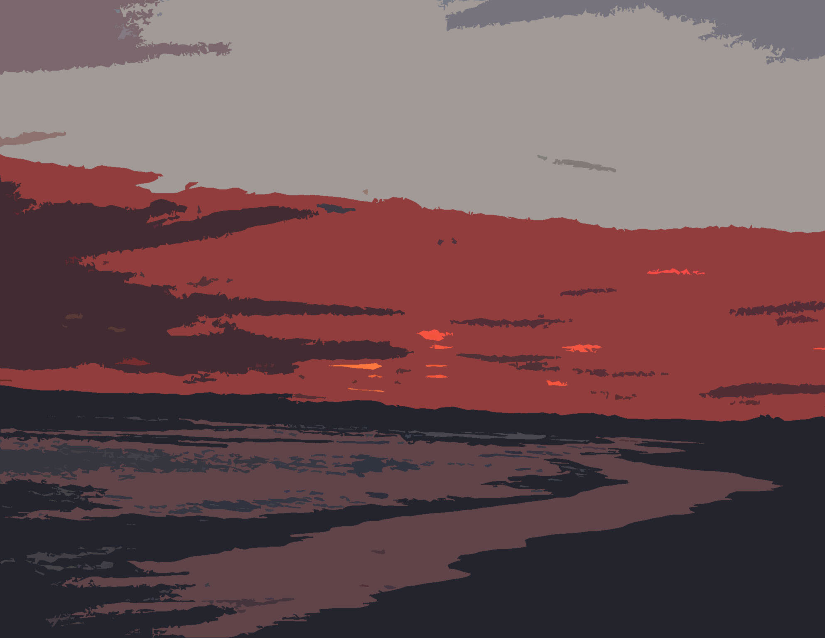
Photography courtesy of Pippa Baxter
Sample school-based assessment outline 1BVAR Explorations

Unit 1BVAR  Explorations |  |  |  | Outcome 1  Visual Arts ideas | Outcome 2  Visual Arts skills, techniques and processes | Outcome 3  Responses to Visual Arts | Outcome 4  Visual Arts in society
Assessment type |  | Weighting | Task description
Art Making | Production  This is a body of work that incorporates resolved artwork/s and documentation of thinking and working practices. | 80% | Task 1: Red Desert and Shimmering Salt: Is the desert really red?  Produce a series of drawings and designs to support you in the development of a mixed media image of a landscape | ✓ | ✓
Art Interpretation | Critical analysis: Response to, analysis and evaluation of artworks. | 10% | Task 2: Critical analysis  Use the STICI framework to analyse the work of a selected artist. Discuss how art elements and principles have been used in their artwork. |  |  | ✓ | ✓
Art Interpretation | Investigation  Case studies involving research and visual analysis focused on Australian and international arts practice. | 10% | Task 3: Symbols used in art  Investigate the media, techniques and symbols used in the artworks of contemporary and traditional Australian artists. |  |  | ✓ | ✓

UNIT 1BVAR Explorations
STUDENT TASK SHEET
TYPE: Production
OUTCOMES: Outcome 1: Visual arts ideas and
Outcome 2: Visual arts skills, techniques and processes
CONTENT: Art making
UNIT CONTEXT: Concepts: landscape, camping ground
Styles and approaches: traditional and contemporary approaches
Materials: mixed media
Meanings and messages: personal response to the local environment
Purposes: communication using symbols

Task: Red Desert and Shimmering Salt. Is the desert really red?

Visual artists, both indigenous and white Australians have developed a language for interpreting the features of the landscape from directly observing, exploring elevated vantage points (as from a hill), aerial perspectives (birds’ eye view) and in some cases have combined multiple perspectives all in the one image.

In this task you will produce a series of drawings and designs to support you in producing a mixed media image of a landscape.

Time for the task
15 weeks.
(Includes class time and requires out of class work time also.)

- This is a semester long unit.
- Activities are to be completed during the week identified in the program outline.
- Tasks not completed in class are to be completed in your time or in accordance with schools assessment policy.

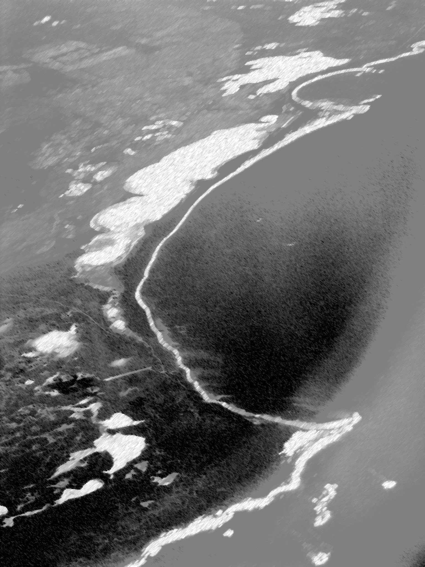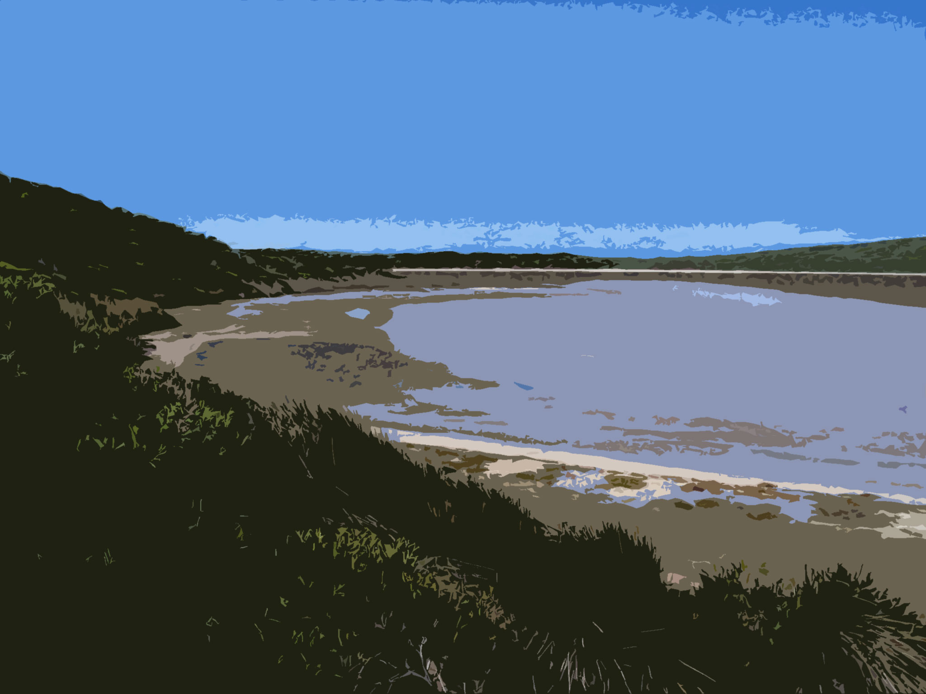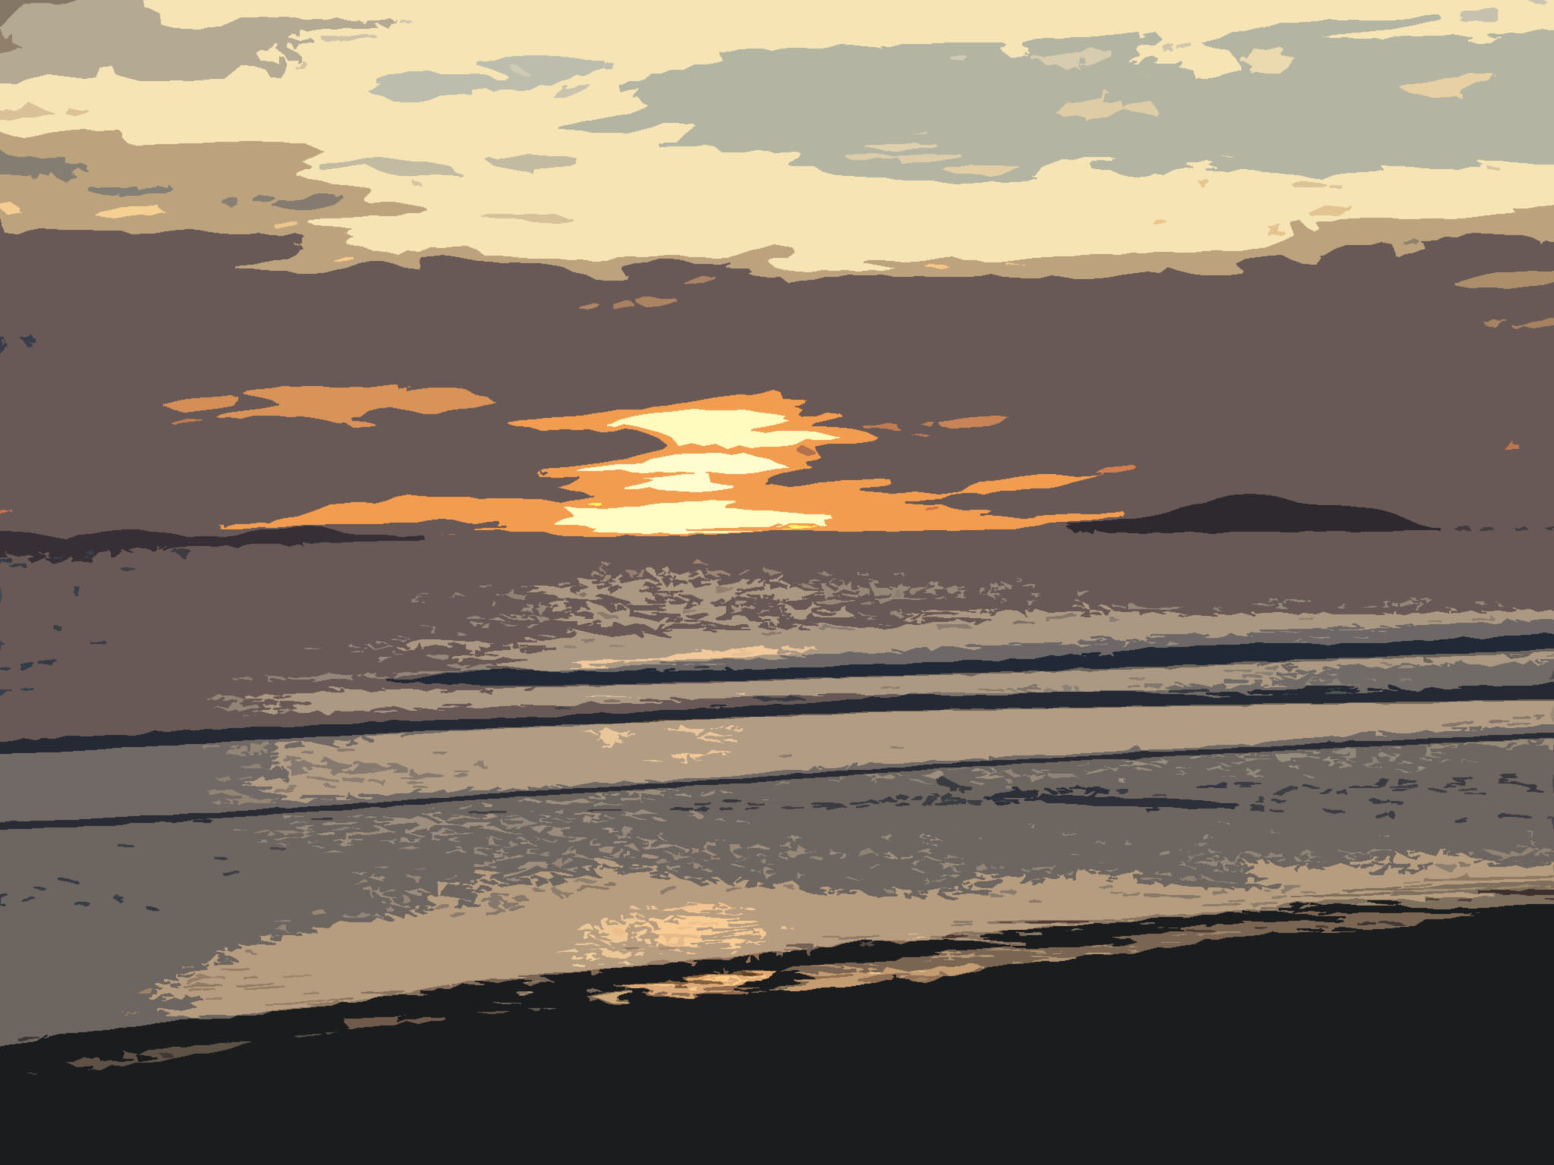
Photography courtesy of Pippa Baxter

What you need to do

Inquiry
- Drawing Exercises
Complete tonal drawings from sections of photocopied photographs of landscape images as well as Google Earth. Use a viewfinder to select and develop areas of interest.
- Use local maps and sources information
Research and collect information about the local environment. Use maps, sketches and photographs to identify features such as roads, distances, flora, fauna, camping conveniences and unique landmarks.
- Concept development
Develop your landscape around the concept of an ideal camping ground. Sketch an image of the site exploring various perspectives, geographic contours and use symbols to represent features such as landmarks or animal tracks. Develop an invented name for your campsite or use “Red Desert and Shimmering Salt” title. Incorporate the image of the site and title together in your design ideas.
- Thumbnail sketches
Develop a series of thumbnail sketches exploring different compositional ideas. Annotate the media and techniques you intend to use. Use your thumbnail sketches to carefully plan your final work.

What you need to do continued

Visual language
- Compositional arrangement
Develop compositional ideas considering the following design principles; balance, unity, illusion of depth, focal point, pattern and rhythm. Consider applying compositional devices that bring action or direct the viewer’s eye through a composition such as directional and diagonal lines. Arrange and assemble shapes exploring positive and negative relationships.
- Textural effects
Plan to develop rich, exciting textural effects in your work that create interest and draw attention.
- Colour Palette
Practice colour mixing using warm and cool acrylic paints. Use tints and tones of the same colours to unify the colour palette of your work.
- Perspective
Interpret the features of the landscape by directly observing. Explore elevated vantage points (as from a hill), aerial perspectives (birds’ eye view) and combined or multiple perspectives all in the one image. Consider illusion of depth using linear perspective, diminishing size of objects and overlapping shapes in your work. Refer to other artists in your investigation of perspective.

Visual influence
- Film viewings
Look at the artwork created by traditional and contemporary artists. Identify media and techniques used by these artists. Explore their compositional devices, textural techniques and colour palettes in your own artwork.

Art forms, media and techniques
- Media Testing
Create a series of media tests exploring the textural markings and colour schemes found in the landscape. Experiment with ways to represent various effects of weathering on the landscape such as dry cracked mud, salt encrusted lakes or the rusty stain of old iron. Explore and combine media such as modelling compound, ink, acrylic paint, PVA glue, water soluble pencils, oil pastels and tissue paper. Experiment with wood shavings, common salt, diatomaceous earth, impasto gel, sand, graphite powder, burnt paper, ink flow markings. Refine your media testing results in preparation for your final work.

Art Practice
- Resolved Artwork
Choose your best thumbnail design idea and produce it as a resolved mixed media artwork. Refer to your media testing when executing your final work.
- Attribution
Ensure you attribute reference to all visual sources used in the development of your artwork. (e.g. the book an image came from, web address where information was downloaded or full details of artist and their work).

Presentation
- Maintaining artwork
Maintain a record showing the development of your work including all experimentation, drawings and design sketches. Keep your work and research organised and in sequence.
- Exhibiting artwork
Complete your final artwork. Identify any materials or equipment needed to display your work e.g. window mount.

Reflection
- Annotations
Maintain annotations that describe the process of experimentation and ideas development. Use a visual journal to plan, evaluate and describe your work.
- Self Evaluation
Complete a written self evaluation for the project. For the resolved image you have produced explain how you have used the art elements and principles in your composition. Elements: line, shape, texture, size, scale and colour. Principles: focal point, balance, unity, illusion of depth, rhythm and pattern. Explain your work and ideas clearly using sentences.

STAGE ONE
FEEDBACK SHEET
ART MAKING
(production)

Inquiry
Well developed drawings and development of ideas. | Satisfactory drawings and development of ideas. | Limited drawing and development of ideas.

Comments_____________________________________________________________________________________________________________________________________________

Visual language
Thoughtful application of visual language demonstrated in work. | Sound application of visual language demonstrated in work. | Limited application of visual language demonstrated in work.

Comments_____________________________________________________________________________________________________________________________________________

Visual influence
Careful consideration given to the use of influences in work. | Some consideration given to the use of influences in work. | Limited consideration given to the use of influences in work.

Comments_____________________________________________________________________________________________________________________________________________

Art forms, media and techniques
Refined application of media and techniques demonstrated in work. | Satisfactory application of media and techniques demonstrated in work. | Minimal application of media and techniques demonstrated in work.

Comments_____________________________________________________________________________________________________________________________________________

Art practice
Well considered selection and effective use of skill and processes. | Satisfactory selection and sound use of skills and processes. | Basic selection and limited use of skills and processes.

Comments_____________________________________________________________________________________________________________________________________________

Presentation
Well documented and presented work | Satisfactorily documented and presented work | Incomplete and poorly presented work.

Comments_____________________________________________________________________________________________________________________________________________

Reflection
Engages in ongoing reflection and evaluation of work to make improvements. | Undertakes some reflection and evaluation of work. | Minimal reflection with limited evaluation of work.

Comments_____________________________________________________________________________________________________________________________________________

Sample Marking Key

Stage 1 Marking Guidelines (production)

Creativity and innovation
10-9 | 8-7 | 6-5 | 4-3 | 2-1
Work is original and shows a personal approach and style. | Work is creative and shows imaginative thinking. | Work is complete and shows some creativity. | Work is very basic showing limited creativity. | Work unoriginal and lacks engagement.
Score:

Skills and processes
10-9 | 8-7 | 6-5 | 4-3 | 2-1
Thoughtful selection and sensitive application of skills and processes used in resolving work. | Suitable selection and appropriate application of skills and processes used in resolving work. | Satisfactory selection and sound application of skills and processes used in resolving work. | Basic selection and minimal application of skills and processes used in resolving work. | Inadequate selection and poor application of skills and processes used in resolving work.
Score:

Use of visual language
10-9 | 8-7 | 6-5 | 4-3 | 2-1
Effective application of visual language demonstrated in artwork. Well developed visual relationships evident. | Appropriate application of visual language demonstrated in artwork. Good visual relationships evident. | Satisfactory application of visual language demonstrated in artwork. Sound visual relationships evident. | Limited application of visual language demonstrated in artwork. Some visual relationships evident. | Minimal application of visual language demonstrated in artwork. Poor visual relationships evident.
Score:

Use of media
10-9 | 8-7 | 6-5 | 4-3 | 2-1
Sensitive use of media demonstrating refined application and handling. | Effective use of media demonstrating competent application and handling. | Satisfactory use of media demonstrating sound application and handling. | Limited use of media demonstrating simple application and handling. | Poor use of media demonstrating minimal application and handling.
Score:

Communication of ideas
10-9 | 8-7 | 6-5 | 4-3 | 2-1
Ideas are highly unique and successfully communicated. | Ideas are imaginative and effectively communicated. | Ideas are basic and adequately communicated. | Ideas are limited and communicated in an obvious way. | Ideas are undeveloped and poorly communicated.
Score:

Total /50

UNIT 1BVAR
TYPE: Critical Analysis
STUDENT TASK SHEET
OUTCOMES: Outcome 3: Responses to visual arts
Outcome 4: Visual arts in society
CONTENT: Art interpretation
UNIT CONTEXT: Concepts: landscape, camping ground
Styles and approaches: traditional and contemporary approaches
Materials: mixed media
Meanings and messages: personal response to the local environment
Purposes: communication using symbols
Task:

Describe artworks using specific art language and terminology. Discuss the relationship between elements of artwork and how these elements contribute to meaning.

Use the STICI framework to analyse the work of a selected artist and their work. Discuss how art elements and design principles have been used in the composition.

Time for the task
1 week, includes class time as well as out-of-class working time.

What you need to do

Visual Analysis
- Examine artworks: Graffiti/placemat activity
Study the reproductions of landscapes produced by Australian artists including Robert Juniper and Fred Williams. Complete a graffiti or placemat sheet responding to their work. Write their name in the centre circle and then analyse their artwork according the following headings:
  - ideas and concepts
  - media and techniques
  - elements and principles
  - colour palette.
- Critical Analysis Worksheet: Red Desert and Shimmering Salt
Choose one specific artwork to analyse in more detail. Complete the guided questions on the worksheet Red Desert and Shimmering Salt. Use full sentences to answer.

Personal Response
- Representing the Australian landscape
Explain the relationship between the elements and principles used in the work e.g. line and the illusion of depth, colour and unity, shape and rhythm and pattern. Discuss compositional devices and textural effects you find most appealing about the artwork.

Meaning and Purpose
- Interpreting artworks
What unique features of the Australian landscape have been communicated in the work? Refer to the artist’s compositional devices, colour choice, media choice and textural markings use of colour, media and techniques. How effective do you think the work is in describing the Australian landscape?

Social, Cultural and Historical Contexts
- Film viewing
Watch video “Meet the artist Robert Juniper”. View the way the artist researches, interprets and finally produces a painting of Paynes Find near Meekathara in Western Australia. Make notes about the how the environmental contexts and physical features of the Australian landscape have been interpreted and represented by the artist. Summarise this information in paragraph form.

Ideas and Concepts
media and techniques
colour palette
elements and principles

Critical Analysis Questions
Red Desert and Shimmering Salt Name
 | Analyse and decode the painting using the following guided questions.
Artist’s name ____________________________________
Title of artwork ____________________________________
Media and dimensions ____________________________________

1 | List 10 ideas and feelings communicated by the artist e.g. vast distance.
2 | Where has the artist located the focal point or (special point of interest to grab your attention) Explain this point. N.B. There may be two or even three.
3 | How has the artist composed the painting? What design principles have been used e.g. is it symmetrically or asymmetrically balanced?
4 | Where can you find areas of rhythm and pattern? i.e. have shapes been repeated over the picture space.
5 | Can you find symbols of the Australian landscape in the work? i.e. water holes, camp sites, windmills? Make a list of all the ones you can identify.
6 | How does the artist achieve an illusion of space, depth and distance? Is there aerial view? Are there overlapping shapes? Are the objects diminishing in size from foreground to background?
7 | How has the artist unified the composition? This is achieved most often by the choice and application of colour.

PERSONAL RESPONSE WORKSHEET NAME: __________________

Artist’s name ____________________________________
Title of artwork ____________________________________
Media and dimensions ____________________________________

IDENTIFY
1. In the box below identify the elements and principles of art.
Elements | Principles
EXPLAIN
2. Explain the relationship between the elements and principles used in the artwork you are critically analysing. e.g. line and the illusion of depth, colour and unity, shape and rhythm and pattern.

DISCUSS
3. Discuss the compositional devices and textural effects you find most appealing about the artwork.

PERSONAL RESPONSE WORKSHEET NAME: __________________

Artist’s name: Robert Juniper

NOTE TAKING
1. In the box below makes notes when viewing the film “Meet the artist Robert Juniper”.
SUMMARISE
2. Summarise what you have learnt about the context and inspiration of Robert Juniper’s artwork in paragraph form.

STAGE ONE
Art Interpretation Marking Key

Visual Analysis
- Identify and discuss key features of artwork/s
- Recognise how the artwork/s have been constructed
- Discuss materials, techniques and processes used in artwork/s
- Interpret and make judgements about the artwork/s.
10–9 | 8–7 | 6–5 | 4–3 | 2–1
Provides a thorough response to artwork identifying and describing the artwork clearly using a wide range of technical art language. | Provides an objective response to artwork discussing the artwork in detail using appropriate art language. | Can identify and describe the main features of the artwork and its construction using some art language. | Uses personal feelings to provide literal and/or subjective response to the artwork using limited art language. | Inadequate response and description of the artwork with minimal use of art language.
Personal Response
- Express personal opinions about the artwork/s
- Support opinions with evidence from artwork/s.
10–9 | 8–7 | 6–5 | 4–3 | 2–1
Provides informed opinions and relevant interpretations that are clearly justified with evidence. | Provides considered opinions interpretations that are supported with reasons. | Discusses personal opinions and interprets specific features of artwork. | Gives some opinions and limited interpretation of artwork. | Little or no opinions or interpretation of artwork given.
Meaning and Purpose
- Offer reasons for why the artwork was produced
- Interpret the meaning/s communicated by the art work/s
- Discuss alternative readings of artwork/s.
10–9 | 8–7 | 6–5 | 4–3 | 2–1
Provides a detailed response that interprets the meanings, messages, ideas and attitudes communicated in artwork. | Provides a clear response that connects form, style, purpose and meanings communicated in artwork. | Satisfactory response that identifies the key ideas and meanings communicated in artwork. | Limited response with literal interpretation of meanings communicated in artwork. | Inadequate response with little attempt to discuss the meaning of the artwork.
Social, cultural and historical contexts
- Discuss the context of artist practice and gives examples of their work
- Discuss the social, cultural and historical influences on the work of selected artists
- Identify the impact of artists on broader context of art practice, production and reading.
10–9 | 8–7 | 6–5 | 4–3 | 2–1
Comprehensive understanding of the context and critical discourse surrounding artists and their work. | Sufficiently detailed understanding of the context surrounding artist/s and their work. | Satisfactory understanding of the context surrounding artist/s and their work. | Limited understanding of the context surrounding artist/s and their work. | Limited understanding of the context surrounding artist/s and their work.

Total marks /40

UNIT 1BVAR
TYPE: Investigation
STUDENT TASK SHEET
OUTCOMES: Outcome 3: Responses to visual arts
Outcome 4: Visual arts in society
CONTENT: Art interpretation
UNIT CONTEXT: Concepts: landscape, camping ground
Styles and approaches: traditional and contemporary approaches
Materials: mixed media
Meanings and messages: personal response to the local environment
Purposes: communication using symbols

Task:

Investigate the media, techniques and symbols used in contemporary and traditional artworks of Australian artists.

Time for the task
3 weeks, including some class time and as well as out of class working time.

What you need to do

Personal Response
- Colour investigation
Select an artwork by either a traditional or contemporary Australian artist whose use of colour, compositional devices or textural detail you find interesting. Describe why you find their work appealing. Make a sample palette recreating the colours and textures of their work. Use these media tests in the development of your own artwork.

Meaning and Purpose
- Symbols in art
Study Simon Nevill’s sketch maps of Burra Rock, Cave Hill and Peak Charles in the Goldfields. Identify symbols used to communicate polar orientation, camping conveniences, off-roading and walk tracks, geographical landmarks, distances above sea level, animal and plant habitats, as well as, natural water features or water supply. Select a central desert artwork that makes use of symbols. Research and explain the meaning or story behind the work. What symbols will you develop in your own work?

Nevill Simon, Travellers Guide to the Parks and Reserves of Western Australia, South Fremantle
Distributed by Simon Nevill Publications, 2000

Social, Cultural and Historical Contexts
- Film viewing
View video “Indigenous Artists of the Central Desert”. Examine how they interpret the landscape according to their tribal and environmental customs. Identify five different painterly techniques used by these artists. Discuss how these techniques are unique to their specific context and culture. Explore some of these techniques in the development of your own work.

STAGE ONE
Art Interpretation Marking Key
Personal Response
- Express personal opinions about the artwork/s
- Support opinions with evidence from artwork/s.
10–9 | 8–7 | 6–5 | 4–3 | 2–1
Provides informed opinions and relevant interpretations that are clearly justified with evidence. | Provides considered opinions interpretations that are supported with reasons. | Discusses personal opinions and interprets specific features of artwork. | Gives some opinions and limited interpretation of artwork. | Little or no opinions or interpretation of artwork given.
Meaning and Purpose
- Offer reasons for why the artwork was produced
- Interpret the meaning/s communicated by the art work/s
- Discuss alternative readings of artwork/s.
10–9 | 8–7 | 6–5 | 4–3 | 2–1
Provides a detailed response that interprets the meanings, messages, ideas and attitudes communicated in artwork. | Provides a clear response that connects form, style, purpose and meanings communicated in artwork. | Satisfactory response that identifies the key ideas and meanings communicated in artwork. | Limited response with literal interpretation of meanings communicated in artwork. | Inadequate response with little attempt to discuss the meaning of the artwork.
Social, cultural and historical contexts
- Discuss the context of artist practice and gives examples of their work
- Discuss the social, cultural and historical influences on the work of selected artists
- Identify the impact of artists on broader context of art practice, production and reading.
10–9 | 8–7 | 6–5 | 4–3 | 2–1
Comprehensive understanding of the context and critical discourse surrounding artists and their work.  Significant connections and stylistic influences made between case studies and development of own practice. | Sufficiently detailed understanding of the context surrounding artist/s and their work.  Strong connections made between case studies and development of own practice. | Satisfactory understanding of the context surrounding artist/s and their work.  Clearly illustrates the links between case studies and development of own practice. | Limited understanding of the context surrounding artist/s and their work.  Simple or obvious links made between case studies and development of own practice. | Limited understanding of the context surrounding artist/s and their work.  Little or no links made between case studies and development of own practice.

Total marks /30

UNIT OUTLINE – 1B VAR: Explorations

SCHEDULE FOR TEACHING
WEEK | LEARNING PROGRAM  Time duration 1 semester (15 Weeks) | ASSESSMENT | TEACHER CHECKPOINTS
1 | Introduction and Expectations-assessment requirements  - Overview of Visual Arts Course 1BVAR.  - Unit Content.  - Expectations, responsibilities and goal setting.  Introduce Assessment Tasks  - Production, Critical Analysis & Investigation.  - Expectations and requirements.  - Due dates.  Unit Focus: Explorations - Landscape  Red Desert and Shimmering Salt  Is the desert really red?  Australia is the driest inhabited continent on earth. It has the flattest, the oldest and the least fertile soils. Most people live on the coastal fringes and cross over the hot arid interior by aeroplane. Visual artists, both indigenous and white Australians have developed a language for interpreting the features of the landscape from directly observing, exploring elevated vantage points (as from a hill), aerial perspectives (birds’ eye view), as well as, combining multiple perspectives all in the one image.  Produce a mixed media image of a landscape. | Introduce  All tasks for Unit and requirements. | Organise resources  - Hand out and group discussion of course. requirements.  - Check all students have folio.  - Order materials – Mixed media for drawing and investigation techniques and resolved artwork.  - Organise resources – Visuals, examples, posters, videos and photocopied handouts.  - Show visuals of aerial photos of landscapes – data projector/laptop.  - To motivate students involvement in program research and record through drawing exercises landscape images from Google Earth.
1 & 2 | Inquiry  Complete the following observation and media testing exercises in preparation for the final resolved studio artwork.  Drawing exercise Using a viewfinder to make a tonal drawing of a section of a photocopied landscape.  Drawing exercise. Using a viewfinder make a black/white felt pen study from a section of a photocopied landscape. Use fine a bullet felt tip pens. Surround the viewfinder shape with either a round or rectangular shape. Put the photo copy away. ‘Spill’ out into the enlarged area with appropriate shapes of your own design. | Production  - Drawings and investigations of landscape images.  - Tonal drawing from section of photocopied landscape.  - Use a viewfinder to make a black/white felt pen study of landscape.  - Attribute reference to landscape source. | Teacher demonstration  - Demonstrate drawing exercises.  - Show examples of best practise.  - Demonstrate how to annotate design work.  - What are you doing? Why? What media are you using?
3 | Painting exercise  Prepare a grey-scale of rectangular shape with acrylic paint. Arrange the cool greys (cobalt blue) and warm greys (warm red) to occur on opposite sides of the rectangle with the lightest greys on the sides and darkest greys to meet in the centre. | Production  - Prepare a grey-scale (rectangular in shape) with acrylic paint. | Teacher demonstration  - Demonstrate a grey-scale in a rectangular shape with acrylic paint.
3 | Drawing and cutting exercise  Make a small viewfinder of only 3 x 3 cm circle or square with lithograph paper. Select an interesting section of your black/white drawing. Scale this up to aprox.12 x 12 on lithograph paper. Using carbon paper, transfer the shapes onto the grey scale painting. Cut out these shapes and reassemble them onto black card in a similar positive /negative proportion as you have on your original drawing. | Production  - Media experimentation of reassembling painted shapes onto black card in a positive /negative design. | Teacher demonstration  - Demonstrate and complete drawing and cutting exercise.
4 | Visual Analysis  Refer to the STICI framework to increase students understanding of describing and evaluating artworks. Discuss how to describe artworks using specific art language and terminology. Discuss relationship between elements of artworks. Structure responses to artworks using the following activities.  Complete small group activity – Graffiti or Placemat. Study reproductions of landscapes produced by Australian artists e.g. Robert Juniper, Fred Williams, and Margaret Woodward. Write the artists’ names in the centre circle. Name recognisable shapes from the painting and describe the media and techniques the artist has used to make the shape.  Complete small group activity – Graffiti or Placemat. Study reproductions of the landscape images write down all the colours you see. These must be accurate e.g. cobalt blue over burnt umber.  Individual writing and recording exercise. Choose one painting to study more closely.  Record the answers on A3 paper and store in your Visual Diary. See the worksheet ‘Red Desert & Shimmering Salt’. | Critical Analysis  - Complete visual analysis of selected painting naming recognisable shapes and describing the media and techniques the artist has used to make the shape.  - Complete visual analysis of selected painting naming the colours used.  - Complete the worksheet ‘Red Desert & Shimmering Salt’. | Organise resources  - Photo copy STICI hand outs.  - Prepare and organise for small group activity – Graffiti or Placemat.  - Demonstrate Individual writing and recording exercise.
5 | Investigate Colour Palette used by your selected artist – make a sample palette and name colours.  What are warm colours?  What are cool colours? | Investigation  - Complete painted sample of colour palette. | Teacher demonstration  - Demonstrate painting of colour palette.
6 | Investigating and classifying  Study author Simon Nevill’s sketch maps of Burra Rock, Cave Hill and Peak Charles in the Goldfields. For each site, classify the information he gives you into 7 main headings: 1 Roads and distances. 2 Flora and Fauna. 3 Landscape Features. 4 Camping Conveniences (record the symbols) 5 Height (above ground level) 6 Tracks and 7 History. | Investigation  - Study author Simon Nevill’s sketch maps and classify information. | Teacher demonstration  - Show examples of best practice.
6 | Diagramming, listing and labelling  Begin by making a list of all the things you will need to go on a successful camp for a week. Use your imagination to design an ideal camping site. Sketch the site and label the features of your camp. Invent a name for your camp site. Include a reference key of symbols. Be sure to identify the visiting animals by their tracks. | Production  - Design, sketch and label your own imaginary campsite. | Teacher demonstration  - Show examples of best practice.
7 | Lettering exercise  Produce a cover page for the project. Use either the invented name of your camp or; “Red Desert and Shimmering Salt” title. Make the letters tight but not touching. Sketch the camp site design into the background the letters and then colour with inks on damp paper for special effect. | Production  - Produce a cover page for the project. | Teacher demonstration  - Demonstrate Lettering exercise.
8 & 9 | Media testing and labelling  Trial and experiment with materials and processes. Make a series of media tests to interpret the textural markings and colour schemes you have seen in the paintings and on the films about the artists studied so far.  Investigate colour palette by exploring mixing colours.  Use a variety of media: modelling compound, ink, acrylic paint, PVA glue, water soluble pencils, water soluble oil pastels, tissue paper, feathers, salt crystals, vinegar, plaster bandage, burnt paper. Use a variety of tools to make dots, suction marks and drag markings. Collage papers together.  Use materials to mask out so that you can make straight lines or create a resist by coating over a colour with wax to preserve its appearance when other colours are painted on top.  How will you represent the various effects of weathering on the landscape?  The effects of fire and burning in progress, the effects of rippling water, effects of water/mud flowing over shallow ground. The effects of salt encrusted lakes. The effects of overlapping hills in the distance. The effects of parched cracked ground. The effects of man-made features such as fences, roads and rail tracks.  Label all your media testing tests with comments, as to which media you used and the specific effects you have achieved. | Investigation  - Samples of comprehensive media testing using a variety of media to represent the various effects of weathering on the landscape.  Production  - All samples must be labelled with comments (annotations) as to which media you used and the specific effects you have achieved. | Teacher demonstration  - Show teacher samples.  - Provide a list of required media samples.
10 | Resolved artwork  Choose an image from your diary so far or choose a photograph or two that appeal to you to develop your mixed media landscape.  Planning for good composition  Choose your best thumbnail. Draw at least four thumbnail compositions (small sketches) of possible alternative ideas for resolved artwork. In each sketch identify all the principles of good composition in text alongside the thumbnail.  Identify in order:  - Illusion of depth: overlapping shapes  - linear perspective.  - aerial perspective.  - elevated view.  - diminishing size of objects.  - overlapping shapes.  - Balance (either symmetrical or asymmetrical balance).  - Unity (usually through the artist’s selection of colour).  - Focal Point (a main point of interest to catch the viewers’ eye).  - Rhythm and pattern (repetition of same or similar shape).  The enemy of the eye is visual boredom.  Here are some good devices for making exciting compositions.  - Make use of diagonal lines that bring action and directional lines that direct the viewer’s eye around the composition.  - Plan for fascinating textural effects that want you to look more closely.  - Make a list of the colours you will use before you begin. Tints and tones of the same colours unify the image.  - Determine focal point. | Production  - Evidence of planning for resolved artwork with annotations identifying the principles of composition. | Teacher demonstration  - Show examples of planning for resolved artwork – teacher and student samples.
11, 12, 13 | Resolved artwork  Produce your resolved artwork referring to your media testing. | Production  - Produce your resolved artwork. | Discussion  - Discuss & select exhibition space.  - Mount “Name” tags for display.  - Photograph art works.  - Prepare scaffold for self evaluation.
14 | Reflection  Complete self evaluation for the project. For the resolved image you have produced explain how you have used the principles of composition. Explain in sentences. Each principle in turn.  Completion of all student work. | Production  - Complete self evaluation for the project.
15 | Hand in and display work  Hand in body of work for final assessment. | - Check all assessments tasks are completed.  - Display of resolved artwork. | - Teacher to complete final assessment of body of work.

Course writers M.Verstegen, Pippa Baxter.

Please note that this course has been implemented in 2007 and is a work in progress.

2AVAR
Differences

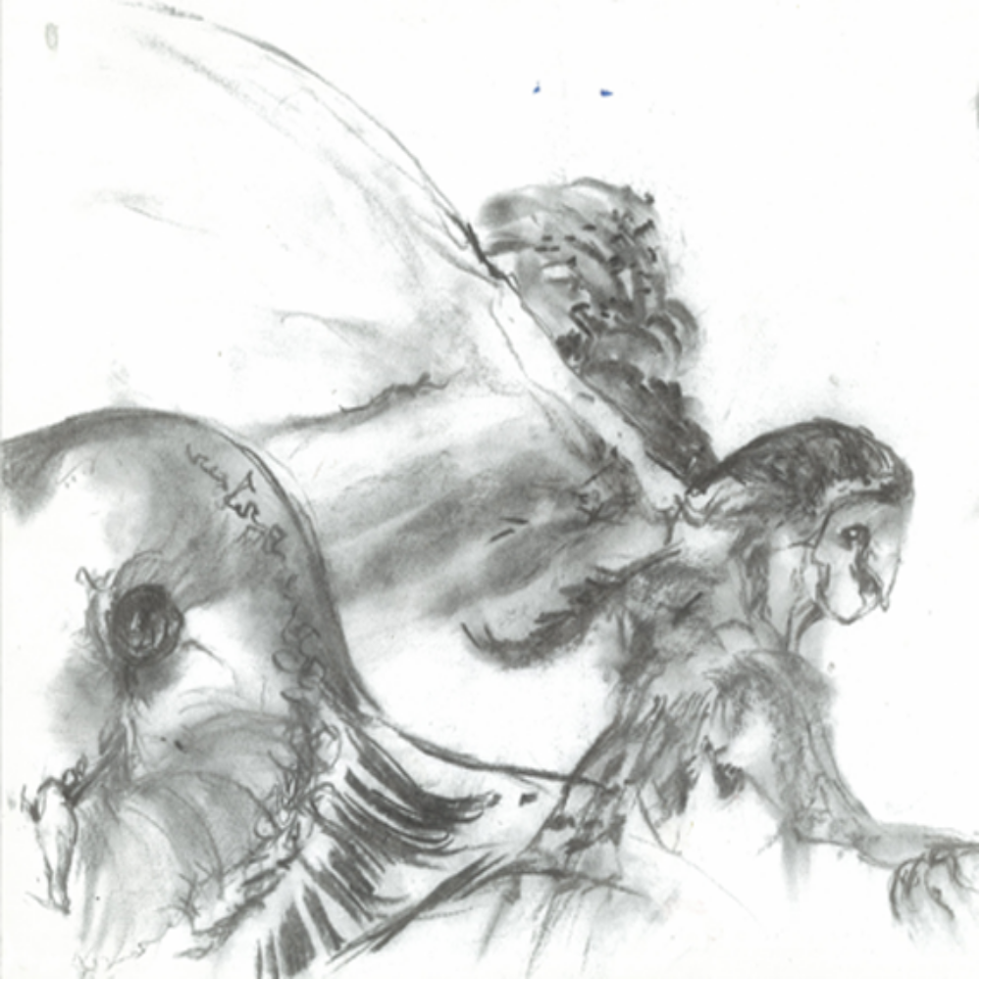Charcoal sketch by Pam Yordanoff
Sample school-based assessment outline 2AVAR Differences

Unit 2AVAR  Differences: ‘of the animal’ |  |  |  | Outcome 1  Visual Arts ideas | Outcome 2  Visual Arts skills, techniques and processes | Outcome 3  Responses to Visual Arts | Outcome 4  Visual Arts in society
Assessment type |  | Weighting | Task description
Art Making | Production  This is a body of work that incorporates resolved artwork/s and documentation of thinking and working practices. | 50% | TASK 1:  Explore and produce a work combining observational drawing, mixed media and photography to the theme ‘Of the Animal’. | ✓ | ✓
Art Interpretation | Critical analysis  Response to, analysis and evaluation of artworks. | 25% | TASK 2:  Image Analysis (in-class) |  |  | ✓ | ✓
Art Interpretation | Investigation  Case studies involving research and visual analysis focused on Australian and international arts practice. | 25% | TASK 3:  Investigate and compare the work of Whiteley, Banksy and other selected contemporary artists. |  |  | ✓ | ✓

UNIT 2AVAR Differences
STUDENT TASK SHEET
TYPE: Production
OUTCOMES: Outcome 1: Visual arts ideas and
Outcome 2: Visual arts skills, techniques and processes
CONTENT: Art making
UNIT CONTEXT: Concepts: anthromorphic
Styles and approaches: Brett Whiteley and Banksy
Materials: mixed media
Meanings and messages: ‘of the animal’
Purposes: expression

Task: Of the Animal

You are required to produce a body of work on the theme “Of the Animal”. The final studio piece will incorporate observational drawings, photography and mixed media.
You are required to explore a range of wet and dry drawing materials, alternative grounds and collage possibilities with a particular focus on mixed media approaches.
Factors to be considered during inquiry are:

- drawing from life; manipulating and extending observational drawings
- incorporation of photography, and
- use of other creative methods to develop anthromorophic hybrid forms.

Time for the task
15 weeks.
(Includes some class time and requires out of class work time also.)

- This is a semester long unit.
- Activities are to be completed during the week identified in the program outline.
- Tasks not completed in class are to be completed in your time or in accordance with schools assessment policy.

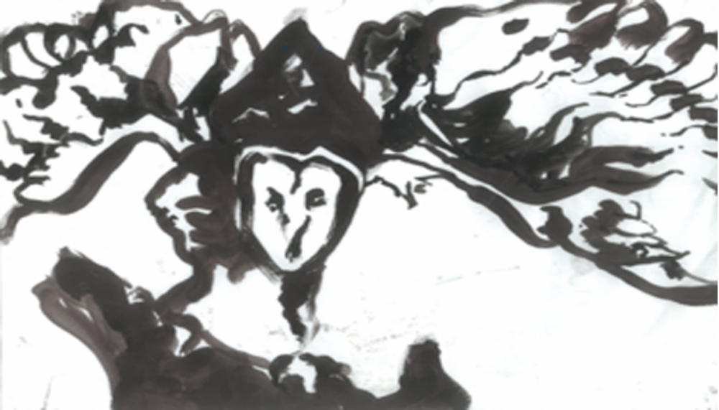Ink sketch by Pam Yordanoff
What you need to do

Inquiry
- Produce a series of black and white observational drawings of animal specimens hired from a local museum, exploring charcoal, white conte on white, grey or black medium/small-scale paper.
- Develop a series of thumbnail sketches exploring different compositional ideas. Annotate the media and techniques you intend to use. Use your thumbnail sketches to carefully plan your final work.

Visual language
- Take a series of black and white photographs exploring visual language, such as texture, contrast and movement. Focus on using a range of camera shots (close-ups, distance or action shots) to capture expressions, postures and interesting features of animals in caged living environments and that you feel you could use to communicate or comment on aspects of the human existence.

Visual influence
- Examine the exploratory sketches and photo-collage works of the ‘Zoo series’ created by Brett Whiteley.
- Collect examples of artwork by graffiti artist, Bansky and make notes on the techniques he uses in his work.
- Complete a series of 1-5 minute sketches of zoo animals using black ink and pen on paper, using a similar style as Brett Whiteley.
- From these sketches develop larger-scale ink drawings exploring pen and brush drawing techniques.
- Research ideas, images, artworks and information needed to strengthen and resolve the conceptual ideas and plans for your final studio work.

Art forms, media and techniques
- Complete two small-scale mixed media drawings;
- one using collage elements cut from photo’s taken at the zoo
- the other using ink, paper stencils and atomisers

Art Practice
- Make a series of thumbnail sketches of compositional designs and continue exploring techniques in the development of human/animal hybrids
- Finalise your ideas by producing a large scale work that makes comment on human existence and relationship between animals and their environment.

Presentation
- Compile a ‘work in progress’ presentation for your peers to review prior to commencing your final studio work. This is an opportunity for feedback, constructive criticism and allows you to review and make any improvements to your work or ideas, prior to commencing your final work.
- Display your work in a public exhibition.

Reflection
- Annotate the origin and evolution of your ideas and decisions made during the planning and creation of your final studio work.
- Use a self-evaluation framework to analyse the success of your work.
- Use your annotations and self evaluation to write a 300 word artist statement about the resolution of your ideas and development of the final art work.

STAGE TWO
FEEDBACK SHEET
ART MAKING
(production)

Inquiry
Thorough exploration of ideas using a variety of drawings and investigative approaches. | Satisfactory exploration of ideas showing some drawing and investigative approaches. | Basic exploration of ideas showing limited drawing and investigative approaches.

Comments_____________________________________________________________________________________________________________________

Visual language
Highly competent exploration and manipulation of visual language | Sound exploration and manipulation of visual language | Limited exploration and manipulation of visual language

Comments_____________________________________________________________________________________________________________________

Visual influence
Highly considered influences demonstrated in work | Sound consideration given to the use of influences in work | Limited consideration given to the use of influences in work

Comments_____________________________________________________________________________________________________________________

Art forms, media and techniques
Excellent application of media and techniques used to communicate intended meaning and purpose | Competent application of media and technique demonstrated in work | Limited application of media and techniques demonstrated in work

Comments_____________________________________________________________________________________________________________________

Art practice
Refined use of skills and processes showing a high level of discernment. | Satisfactory use of skills and processes demonstrated in work. | Basic use of skills and processes demonstrated in work.

Comments_____________________________________________________________________________________________________________________

Presentation
Work well documented and presented to a very high standard. | Work completed, soundly organised and presented | Work incomplete, poorly organised and presented.

Comments_____________________________________________________________________________________________________________________

Reflection
Ongoing reflection and evaluations undertaken to improve and explain work. | Satisfactorily reflects on and evaluates the process and product of work undertaken | Minimal reflection and evaluation of work undertaken.

Comments_____________________________________________________________________________________________________________________

Sample Marking Key

Stage 2 marking guidelines (production)

Creativity and innovation
10-9 | 8-7 | 6-5 | 4-3 | 2-1
Work is strong and ambitious demonstrating originality, creativity and flair. | Work is expressive and shows a sound level of creativity and originality. | Work is imaginative and shows some elements of creativity and originality. | Work is very basic showing limited creativity and originality. | Work unoriginal, and lacks engagement.
Score:

Communication of ideas
10-9 | 8-7 | 6-5 | 4-3 | 2-1
Ideas successfully communicated in articulate and expressive work. | Ideas effectively communicated in direct and uncomplicated work. | Literal, obvious or superficial ideas communicated. | Limited ideas communicated. | Ideas insufficiently or ineffectively communicated.
Score:

Use of visual language
10-9 | 8-7 | 6-5 | 4-3 | 2-1
Highly developed application of visual language demonstrated in artwork. Successful visual relationships evident. | Competent application of visual language demonstrated in artworks. Sound visual relationships evident. | Simple application of visual language demonstrated in artwork. Few visual relationships evident. | Minimal application of visual language demonstrated in artwork. Unsuccessful visual relationships evident. | Weak application of visual language demonstrated in artwork.
Score:

Use of media
10-9 | 8-7 | 6-5 | 4-3 | 2-1
Highly competent selection and use of media demonstrating consistent application and handling. | Appropriate selection and use of media demonstrating satisfactory application and handling. | Basic selection and use of media demonstrating sufficient application and handling. | Minimal selection and use of media demonstrating inappropriate application and handling. | Insufficient exploration and use of media demonstrating poor application and handling.
Score:

Skills and processes
10-9 | 8-7 | 6-5 | 4-3 | 2-1
Highly considered selection and application of skills and processes used to resolve work. | Appropriate selection and application of skills and processes used to resolve work. | Limited selection and application of skills and processes used to resolve work. | Inappropriate selection and application of skills and processes used to resolve work. | Poor selection and application of skills and processes used to resolve work.
Score:

Total /50

UNIT 2AVAR Differences
TYPE: Critical Analysis
STUDENT TASK SHEET
OUTCOMES: Outcome 3: Responses to visual arts
Outcome 4: Visual arts in society
CONTENT: Art interpretation
UNIT CONTEXT: Concepts: anthromorphic
Styles and approaches: Brett Whiteley and Banksy
Materials: mixed media
Meanings and messages: ‘of the animal’
Purposes: expression
Task:

Image Analysis (in-class)
You are to complete an in-class analysis that responds to the following question. The will be provided at the time of the assessment. This assessment is to prepare you for the external examination.

Question:
Select one of the following images:
Image B, Image C, Image D, Image E, Image F or Image G from the illustration Book and answer the following question:

Explain the meanings that are communicated by the artwork giving consideration to:
- The subject matter
- Use of materials, techniques and technologies
- Use of elements and principles
- Social, cultural and historical references

Support your response by referring to specific features of the artwork and by offering a variety of interpretations.

Time for the task
1 week, in class time (week 8)

What you need to do

Visual Analysis
- Examine the artwork carefully. Make notes about the work using the 4 frames; subjective, structural, cultural and postmodern.

Personal Response
- Explain the relationship between the elements and principles used in the work. Discuss compositional devices used. How effective is the work?

Meaning and Purpose
- What ideas or meanings are communicated in the work? What is the artist trying to communicate and what techniques and processes have they used to express their ideas?

Social, Cultural and Historical Contexts
- Discuss any social, cultural or historical references in the work. Can you identify it stylistically? Is it contemporary or more traditional in its approach?

Stage 2
Art Interpretation Marking Key

Visual Analysis
- Identify and discuss key features of artwork/s
- Recognise how the artwork/s have been constructed
- Discuss materials, techniques and processes used in artwork/s
- Interpret and make judgements about the artwork/s.
10–9 | 8–7 | 6–5 | 4–3 | 2–1
Detailed analysis that explains both the aesthetic qualities and conceptual meanings communicated with selective use of art language. | Objective analysis of artwork and identification of key meanings communicated, using appropriate art language. | Basic analysis focused mainly on the formal aspects and/or key features, using a limited range of art language. | Analysis restricted to being largely descriptive and/or emotive with limited use of art language. | Inadequate analysis and response to question with m minimal use of art language.
Personal Response
- Express personal opinions about the artwork/s
- Support opinions with evidence from artwork/s.
10–9 | 8–7 | 6–5 | 4–3 | 2–1
Articulate own viewpoint and support personal opinions with reference to specific features of artwork/s. | Provides reasons for personal conclusions based on subjective and objective evidence. | Few reasons offered to support opinions and personal conclusions. | Personal opinions stated but not supported with reasons. | Little or no attempt to respond to artwork. No conclusions made.
Meaning and Purpose
- Offer reasons for why the artwork was produced
- Interpret the meaning/s communicated by the art work/s
- Discuss alternative readings of artwork/s.
10–9 | 8–7 | 6–5 | 4–3 | 2–1
Informed and thorough discussion of concepts, meaning, purpose and value of artwork/s, synthesising varied or conflicting interpretations. | Comprehensive interpretation of meanings communicated in artwork/s. | Literal interpretation of artworks/s and their meaning. | Limited description of artwork provided. | Little or no attempt to discuss the meaning and purpose of artwork.  Inadequate response to question.
Social, cultural and historical contexts
- Discuss the context of artist practice and gives examples of their work
- Discuss the social, cultural and historical influences on the work of selected artists
- Identify the impact of artists on broader context of art practice, production and reading.
10–9 | 8–7 | 6–5 | 4–3 | 2–1
Extensive understanding of the context and critical discourse surrounding artists and their work. | Sufficiently detailed understanding of the context surrounding artist/s and their work. | Satisfactory understanding of the context surrounding artist/s and their work. | Limited understanding of the context surrounding artist/s and their work. | Insufficient information of the context surrounding artist/s and artworks.

Total marks /40
UNIT 2AVAR Differences
TYPE: Investigation
STUDENT TASK SHEET
OUTCOMES: Outcome 3: Responses to visual arts
Outcome 4: Visual arts in society
CONTENT: Art interpretation
UNIT CONTEXT: Concepts: anthromorphic
Styles and approaches: Brett Whiteley and Banksy
Materials: mixed media
Meanings and messages: ‘of the animal’
Purposes: expression
Task:

Investigate the media, techniques and artistic practice of Brett Whitley and Bansky. Compare their approach and representation of subject matter. Investigate other contemporary artists.

Summarise your historical research and critical studies of selected works in an essay format. Clearly identify how these artists and their artworks have influenced the development of your own art practice.

Time for the task
3 weeks, including some class time and as well as out of class working time.
Due: Week 9

What you need to do

Visual Analysis
- Brett Whiteley and Banksy
Select an artwork from each of these artists to analyse using the four frames. Make detailed notes about the each of the works. Select and investigate the work of other contemporary artists from either an Australian or international context. Use the frames to analyse their work also.

Personal Response
- Brett Whiteley
Examine selected works of Brett Whiteley’s ‘Zoo Series’. Discuss the qualities of Whiteley’s artwork. Base your observational studies of animals on a similar expressive approach characteristic of Whiteley’s style.
- Banksy
What is your personal response to Bansky’s work? Refer to specific artworks in your response. Explore the techniques used by Banksy in the development of your own ideas.

Meaning and Purpose
- Research
Use a variety of sources to research the work of each artist. Summarise the historical information about each artist under the following heading; biography, inspiration, stylistic approach, influences, ideas communicated, meaning and purpose.

Social, Cultural and Historical Contexts
- Challenging subject, themes and approaches
Identify and discuss the ways in which each artist raises social, cultural, historical ideas in their work. What artistic conventions are used to challenge and provoke? How does each artist achieve their aims?

Stage 2
Art Interpretation Marking Key

Visual Analysis
- Identify and discuss key features of artwork/s
- Recognise how the artwork/s have been constructed
- Discuss materials, techniques and processes used in artwork/s
- Interpret and make judgements about the artwork/s.
10–9 | 8–7 | 6–5 | 4–3 | 2–1
Detailed analysis that explains both the aesthetic qualities and conceptual meanings communicated with selective use of art language. | Objective analysis of artwork and identification of key meanings communicated, using appropriate art language. | Basic analysis focused mainly on the formal aspects and/or key features, using a limited range of art language. | Analysis restricted to being largely descriptive and/or emotive with limited use of art language. | Inadequate analysis and response to question with m minimal use of art language.
Personal Response
- Express personal opinions about the artwork/s
- Support opinions with evidence from artwork/s.
10–9 | 8–7 | 6–5 | 4–3 | 2–1
Articulate own viewpoint and support personal opinions with reference to specific features of artwork/s. | Provides reasons for personal conclusions based on subjective and objective evidence. | Few reasons offered to support opinions and personal conclusions. | Personal opinions stated but not supported with reasons. | Little or no attempt to respond to artwork. No conclusions made.
Meaning and Purpose
- Offer reasons for why the artwork was produced
- Interpret the meaning/s communicated by the art work/s
- Discuss alternative readings of artwork/s.
10–9 | 8–7 | 6–5 | 4–3 | 2–1
Informed and thorough discussion of concepts, meaning, purpose and value of artwork/s, synthesising varied or conflicting interpretations. | Comprehensive interpretation of meanings communicated in artwork/s. | Literal interpretation of artworks/s and their meaning. | Limited description of artwork provided. | Little or no attempt to discuss the meaning and purpose of artwork.  Inadequate response to question.
Social, cultural and historical contexts
- Discuss the context of artist practice and gives examples of their work
- Discuss the social, cultural and historical influences on the work of selected artists
- Identify the impact of artists on broader context of art practice, production and reading.
10–9 | 8–7 | 6–5 | 4–3 | 2–1
Extensive understanding of the context and critical discourse surrounding artists and their work.  Significant formal and conceptual connections and influences made between case studies and development of own practice. | Sufficiently detailed understanding of the context surrounding artist/s and their work.  Strong connections made between case studies and development of own practice. | Satisfactory understanding of the context surrounding artist/s and their work.  Clearly illustrates the links between case studies and development of own practice. | Limited understanding of the context surrounding artist/s and their work.  Simple or obvious links made between case studies and development of own practice. | Insufficient information of the context surrounding artist/s and artworks.  Little or not links made between case studies and development of own practice.

Total marks /40

UNIT OUTLINE – 2A VAR: Differences

SCHEDULE FOR TEACHING
WEEK | LEARNING PROGRAM  Time duration 1 semester (15 Weeks) | ASSESSMENT | TEACHER CHECKPOINTS
1 | Introduction and Expectations-assessment requirements  - Overview of Visual Arts Course 2AVAR  - Unit Content  - Expectations, responsibilities and goal setting.  Introduce Assessment Tasks  - Production, Critical Analysis & Investigation  - Examination Requirements  - Due dates and school submission policy.  Unit Focus: Differences – Of the Animal  You are required to produce a body of work on the theme “Of the Animal”. The final studio piece will incorporate observational drawings, photography and mixed media.  You are required to explore a range of wet and dry drawing materials, alternative grounds and collage possibilities with a particular focus on mixed media approaches.  Factors to be considered during inquiry are:  - drawing from life; manipulating and extending observational drawings  - incorporation of photography, and  - use of other creative methods to develop anthromorophic hybrid forms. | Introduce  All tasks for Unit and requirements. | Organise resources  - Copies of the Visual Arts Course  - Copies of task sheets  - Examples of drawings and artworks based on similar theme and subject.
1 | Inquiry  - Observational drawing from animal display.  - Explore drawing techniques using charcoal and ink. Experiment with dry brush, wet on wet, blending, directional lines and erasing to create strong expressive tonal and line studies.  Brett Whiteley  - Examine selected works of Brett Whiteley’s. Based your observational studies on a similar approach used by Whiteley.  - Select an image to analyse using a critical analysis framework | Production  Investigation | Organise resources  - Images of Brett Whiteley’s “Zoo  - Series”  - Drawing materials  Discussion  - Brett Whiteley developed many artworks based on animals at the London Zoo. Discuss the qualities of his work, style and approach.
2 | Concept development: anthromorphic  - Introduce the anthromorphic concept with a focus on emotive images: pulling on your heart strings, sympathy & empathy.  Visual Influence  - Examine selected works of Brett Whiteley.  Zoo Visit – observed drawing  - Zoo visit taking a series of photos exploring elements and principles, compositional devices like rule of thirds, focal point, leading lines, perspective & depth of field emphasising the feelings of capture, display and enclosure. | Production  Investigation  Production | Discussion  - The frames  Excursion  - The Zoo.
2, 3 | Developing artworks  - Use photographs to develop artwork  - Photos will form the basis of a mixed media drawing a kin to Whitely’s ‘Psssst…..’. | Production | Teacher Demonstration  - Show samples of work.
4,5 | Visual Influence  - Research and explore 2 or 3 animals as a focus. Brainstorm: symbolic meaning, cultural associations, literal references, mythological moral and social ideas and present a series of visual studies.  Investigation  - Undertake historical research on Whiteley and Banksy. Gather biographical information, their inspiration and influences, stylistic approach, ideas communicated, meaning and purpose. | Production  Investigation | Organise resources  - Books, artworks, art journals and magazines.  - Library research, artist statements, education packages, catalogue information
6,7 | Design Development  - Design synetics exercises to challenge by combining, stylising, morphing, hybridising  - Exquisite corpse activity.  Collage  - Develop collage creatures with emphasis on distortion and scale. Enlarge the eyes or mouth to create an emotional sympathy. | Production | Discussion  - Ways to transform ideas and images.  - Refer to selected artists work.
8 | Critical Analysis using 4 frames  - Look at the format of the Stage 2 examination  - Practice responding to images using the 4 frames  - Discuss responses as a class group  Image analysis  - In-class assessment | Critical Analysis | Discussion  - Answering the question  - Design Brief for Stage 2 written exam  Organise resources  - Sample exam and marking key
9,10,  11 | Design Development  - Choose a personal theme to compose an artists’ statement or directive  Exploration and experimentation  - Exploring and experimenting with visual interpretations of an idea  Compositional arrangement  - Compositional devices and background: series of exploratory exercises to develop a context for the work. Look at juxtaposition, mood, text, abstraction.  - Mock up with media experimentation – surfaces, use of experimental drawing techniques, spray, airbrushes, alternative grounds, gesso prepared surfaces, etc | Production  Investigation due  (essay)
12,13 | Art practice: studio production  - Production complemented with a review each week | Production
14,15 | Art practice: studio production  - Artists’ statement refined and display of work | Production

